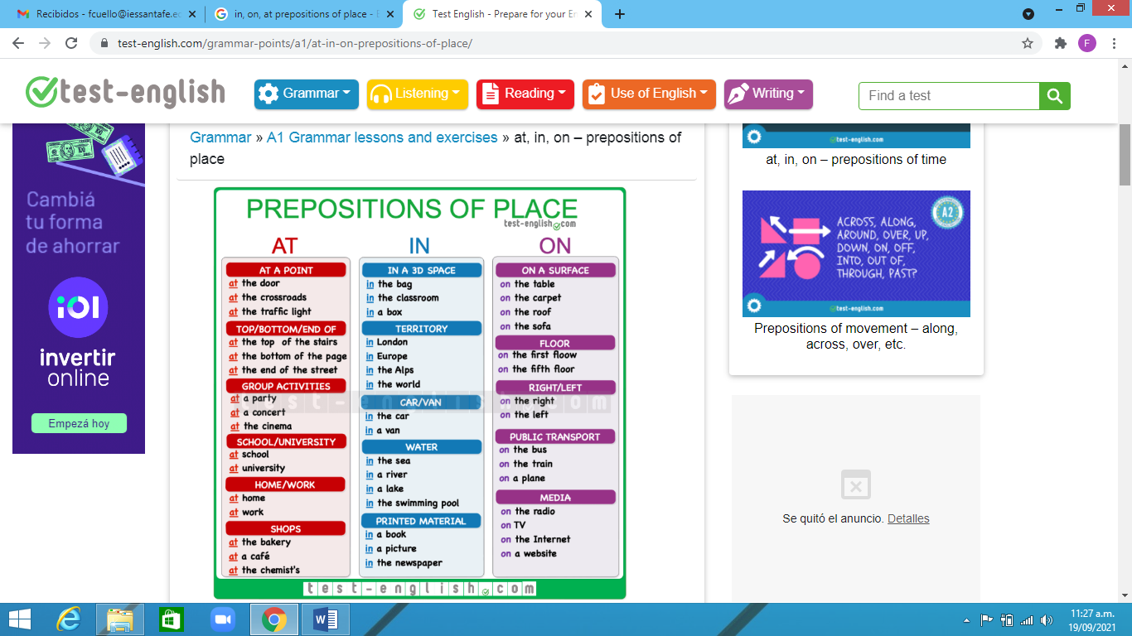

https://test-english.com/grammar-points/a1/at-in-on-prepositions-of-place/
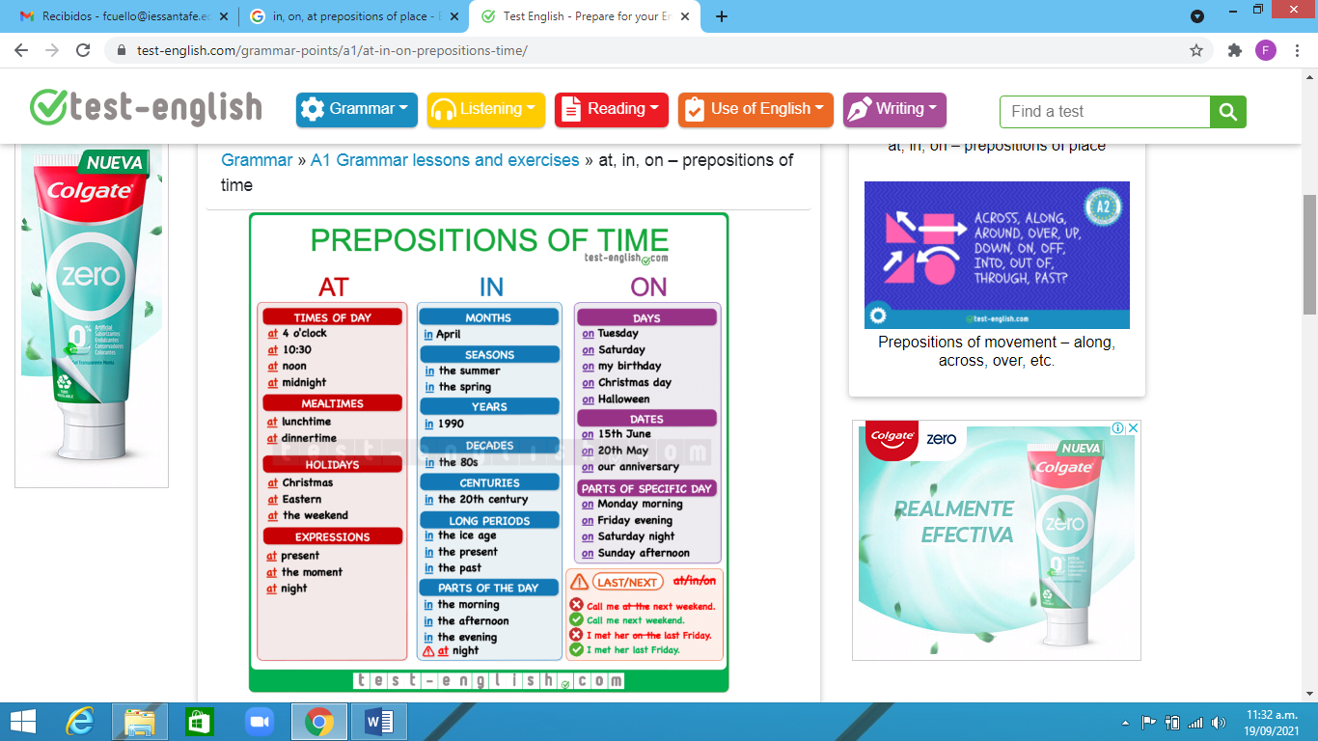

https://test-english.com/grammar-points/a1/at-in-on-prepositions-time/

